Research

# Other Tour Applications

A look into other tour mobile applications to see what other apps do well and what they could improve on.

## 1: ActionTourGuide

1) Each room has an image on the top, with an audio description below. You can swipe between rooms easily without having to leave the page.

**Pros**:

* This is a good way of presenting information as it’s very easy to use.
* Shows a clear image of the room - easy to understand what room is being described

**Cons**:

* Harder to look at a specific room - involves having to swipe through other rooms first
* Requires either headphones or being able to listen on loud speaker - not always ideal

Could replace the audio description with a section of informative text.

2) Floor plan shows the entry and exit points of each rooms using red arrows

**Pros:**

* Easy to understand where the doors are located

**Cons:**

* Can be a bit pointless if both the entry and exit door are the same door

3) Has a list view for each room so the user can select a room from a list rather than looking through images

**Pros:**

* Faster to find a room if you know the name

**Cons:**

* Doesn’t give any additional information about the room other than the name before selecting it

4) Home page has big, clear images of the site, with a brief description below

**Pros:**

* Very easy to see the area in question
* Gives a bit of information before selecting

**Cons:**

* Takes up a lot of space
* Doesn’t give a huge amount of information

## 2: Natural History Museum

1) Has a grid view of all the different attractions (e.g. birds, dinosaurs, halls etc.)

**Pros:**

* Easy to find a certain area of the museum
* Has clear images to describe the section

**Cons:**

* Not a particularly well designed layout
* No other information on the screen

2) Has colour-coded floor plans with images of what is in each area (e.g. the dinosaur section has an image of a dinosaur on the map)

**Pros:**

* Very clear what area is what on the map
* Easier for the user to select that area
* Colour-coded system makes it easy to tell what floor you’re looking on
* Has additional information on map, such as toilet locations and entrance location

**Cons:**

* Takes up space, making it awkward if two areas are close to one another
* Some images might be a bit unclear what they represent (each image is a silhouette, so not always clear what an image is)
* Other than the shape of the room, there is not much information about the contents of the room

3) Integration of a search bar

**Pros:**

* Can search for a specific term (when it works)

**Cons:**

* Not a good integration of a search bar - hard to use
* Not easy to find a specific room
* Not available on every (or even most) screens

## 3: Newcastle Castle

1) Separates the app into different sub-sections (Audio Guides, About, What’s On, History)

**Pros:**

* Avoids having too much information in one place
* Makes it easier to find something from the home page

**Cons:**

* Design is very basic - not very visually appealing

2) Has an image of a specific area, with lots of text below it

**Pros:**

* Has a clear image of the certain area
* Has a lot of information for the user to read

**Cons:**

* Very basic layout
* A lot of information in the same place - could be a bit overwhelming on a first glance

3) Has links to attractions nearby or at the castle

**Pros:**

* Useful to anyone looking to plan trips
* Has a thumbnail to give a bit more information/understanding of the event
* Clean looking

**Cons:**

* Needs to be continually updated over time
* Doesn’t give an exact location before clicking the event

## 4: Empire State Building

1 Has a contents page to direct users to different parts of the app

**Pros:**

* Good separation of information
* Large and easy to click on

**Cons:**

* Only available on the contents page - users have to go back to get to another floor
* Some inconsistency with arrows on each list item

2) Welcome page has an image of the building, taking up the entire screen, directing the users to the contents page

**Pros:**

* Clear introduction to the application
* Visually appealing image of the building

**Cons:**

* A bit pointless as the user has to skip past it every time they load the app - appealing only for a one time use
* Adds an extra step to get to the contents page

3) Has images of the surrounding area (a map-like feature)

**Pros:**

* Shows areas around the building clearly
* Has buttons to display information about the surrounding area

**Cons:**

* Not a very fluid integration of maps
* Low quality images - inconsistent with the rest of the app
* Difficult to use with ease

# Google Maps Integration

Ways to integrate a Google Maps API into our app:

* Location data for the Urban Sciences Building (a marker on a map)
  + Can also provide name, address, and other rich details like ratings, reviews, or contact information
* Get directions from user’s location to the Urban Sciences Building
  + Provides reliable directions between two markers on a map, and estimates for travel time and distance

Link to example usage of Google Maps API: <https://cloud.google.com/maps-platform/> shows example code of using Google Maps in a mobile app.

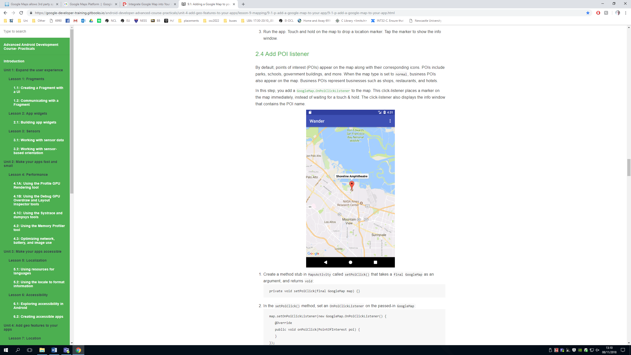Link to step-by-step guide on how to integrate Google Maps into a mobile app: <https://google-developer-training.gitbooks.io/android-developer-advanced-course-practicals/unit-4-add-geo-features-to-your-apps/lesson-9-mapping/9-1-p-add-a-google-map-to-your-app/9-1-p-add-a-google-map-to-your-app.html> includes information on adding different map types, changing the default map location and styling a map.

Image shows how a map may look in a mobile app

Also worth noting that if we require to use google maps for free in our mobile application then we must use the Developer Plan. The Developer Plan is free and may be used, given that the application based on Google Maps is free (!) to use for everyone (!). Maps used with the Developer Plan may contain advertising. <https://ubilabs.net/en/news/google-maps-apis-licensing-2016-04-21>

Other related websites:

<https://blogs.perficient.com/2017/09/20/integrate-google-map-into-your-app/>

<https://developers.google.com/maps/api-key-best-practices>

<https://developers.google.com/maps/faq>

# Heuristics

## 1: Heuristics for UI

* Always keep the user informed on what's going on.
* Should speak users language including symbols (No technical terms).
* Users should be able to undo any mistakes/misguidance they have caused.
* Words and symbols should be consistent.
* Prevent errors from occurring.
* Reduce what the user needs to remember when navigating app by providing information when necessary.
* Should be usable by both experienced and inexperienced users.
* Remove irrelevant information.
* Make errors recognisable so that the user can fix them.
* Provide help when necessary.

## 2: Important Notes for the Design

* All/most parts of the app should be navigable in as few as possible steps.
* Positive responses should be above or to the left of the negative response. E.g. yes and no, submit and cancel, etc.
* Should almost always be able to get home from the current section
* Clear use of icons and don’t make them too small.
* Background colour and font colour should be easy on the eyes.

# Web Design Requirements

## 1: Museum Tour Guides

**Source 1**: <http://www.museumtourguides.com/home/product/british-museum-app-guide/>

**Notes**

This webpage itself is a part of a website promoting a lot of different apps, this is best as a guideline for the front page of our app.

**Pros**

* Links to the app store for iOS/Amazon and Google Play are right at the top, immediately visible. Eye catching and easy to remember where they are
* There are images of the app in use on various screens, and an image gallery you can scroll through to show features.
* Blurb of the app and more detailed information detailed below.

**Cons**

* It lists ‘Top 20’ and ‘Top 125’ with no indication of what these mean, meant to be eye catching?
* No example of features like colour-blind options, audio guides, etc. Website is not very detailed but to be expected as its part of a bigger whole.

## 2: The Louvre

**Source 2:** <https://www.louvre.fr/en/louvre-app>

**Notes**

This webpage is more detailed than the first one, although it’s French it has an English translation and includes more info than the first, and is better organised. Some of the website isn’t relevant to us (like the learning about art tab) but a lot of it is, stuff like detailing exhibitions/events happening in the USB could be a good thing to add (this is also a general Louvre site but I think the events thing could be relevant to us, we can add a general section about the USB).

**Pros**

* Important information is immediately visible, things like the cost of the app/in-app purchases and file size are on the right, and important info about the features of the app are bullet pointed on the left.
* Multiple sections detailing different events/exhibitions happening at the Louvre, tours, etc.
* Short and to the point, you don’t have to scroll to see all the important information about the app.

**Cons**

* Not as eye catching as the other website, no images of the app in use and the text is small and out of the way.
* Large gap at the top of the screen which is empty, we could add images there if we used a similar design but nothing is done with it here, breaks up the page unnecessarily.
* The only part of the page that grabs your attention is the technical information of the app such as size/cost, the actual features of the app should grab your attention more.

## 3: YouVisit

**Source 3:** <https://www.youvisit.com/university-campus-tour>

**Notes**

Very detailed front page with a lot of text, this is more of a web app but the design of the webpage when you click ‘Take a look inside’ is really good, and worth analysing.

**Pros**

* Very detailed main page with an eye catching link to an inner, more functional webpage that’s brief and to the point.
* Inner webpage is formatted very nicely as you scroll down, shows how the app can attract more students to a given university than they would attract otherwise
* Design is excellent, it is formatted very well overall and is pleasing to look at.

**Cons**

* The main page could be a bit too detailed, with nothing to really space out the text. Could be made briefer
* This source doesn’t directly relate to mobile apps, but it shows elements of good website design for marketing/promotion.